Group no: 7
- Faiza Tasnim-(19-41552-3)
- Syeda Faiza Karima-(20-43073-1)
- Sharia Tasnim Adrita-(20-41895-1)
- Sadia Afrin Sara – (20-41834-1)

CLASS Diagram of Medicare:

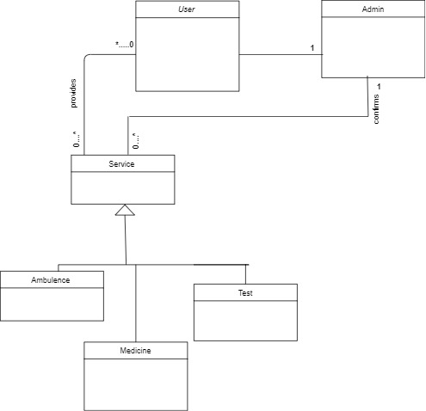

Class Component:
